CET 753
Lab Completion Sheet
Chapter 11

Name: Mark Harming

# | Page | Chapter/Activity | Status | Description
88 | 450 | 11-1 |  | Monitoring and Managing a Service

Screen Shot(s) | Documentation
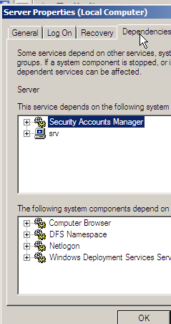

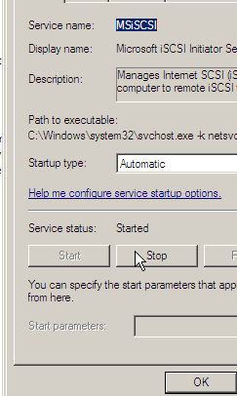

# | Page | Chapter/Activity | Status | Description
89 | 453 | 11-2 |  | Working with Applications in Task Manager

Screen Shot(s) | Documentation
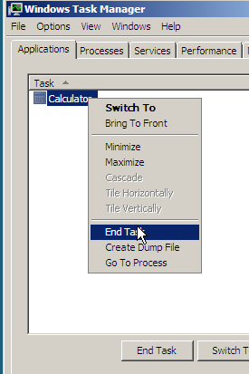

# | Page | Chapter/Activity | Status | Description
90 | 457 | 11-3 |  | Working with Processes in Task Manager

Screen Shot(s) | Documentation
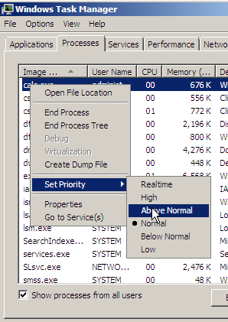

# | Page | Chapter/Activity | Status | Description
91 | 466 | 11-4 |  | Exploring Performance Monitor

Screen Shot(s) | Documentation
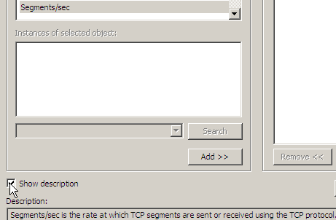

# | Page | Chapter/Activity | Status | Description
92 | 469 | 11-6 |  | Verifying the Disk Counters

Screen Shot(s) | Documentation
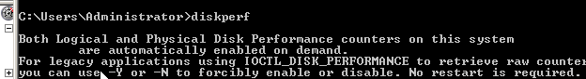

# | Page | Chapter/Activity | Status | Description
93 | 471 | 11-7 |  | Using a Template for A Data Collector Set

Screen Shot(s) | Documentation
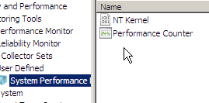  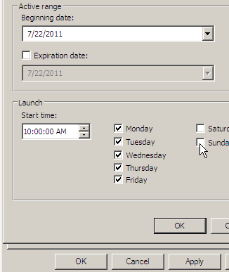  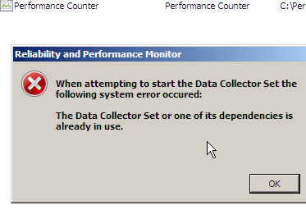  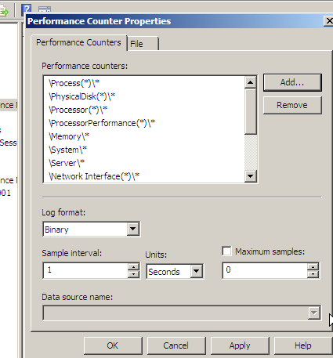 | I received an error near the end of step 7, but this was because I clicked start, and the process was already started.

# | Page | Chapter/Activity | Status | Description
94 | 475 | 11-8 |  | Viewing a Report

Screen Shot(s) | Documentation
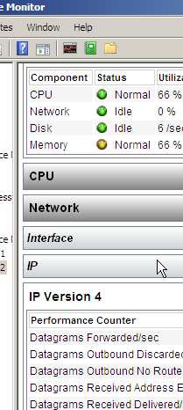

# | Page | Chapter/Activity | Status | Description
95 | 479 | 11-10 |  | Using Reliability Monitor

Screen Shot(s) | Documentation
